# CS 255 System Design Document

## UML Diagrams

### UML Use Case Diagram

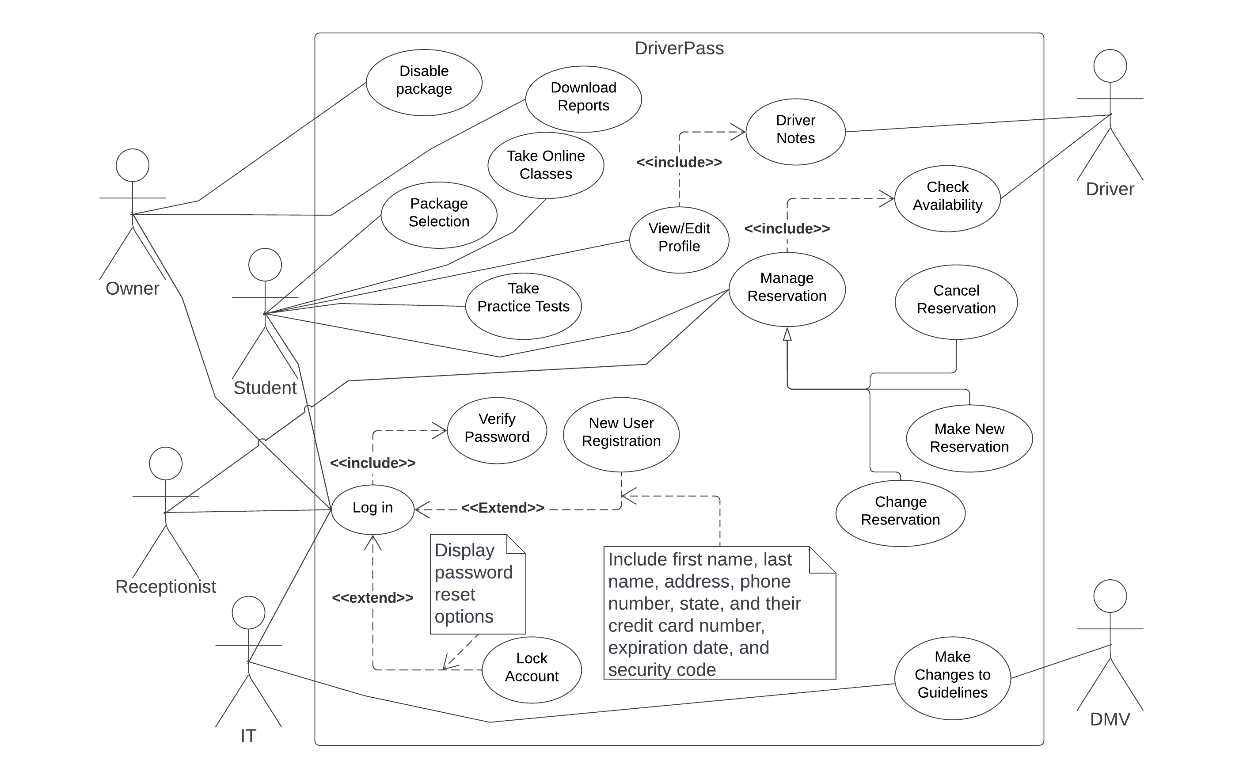

### UML Activity Diagrams

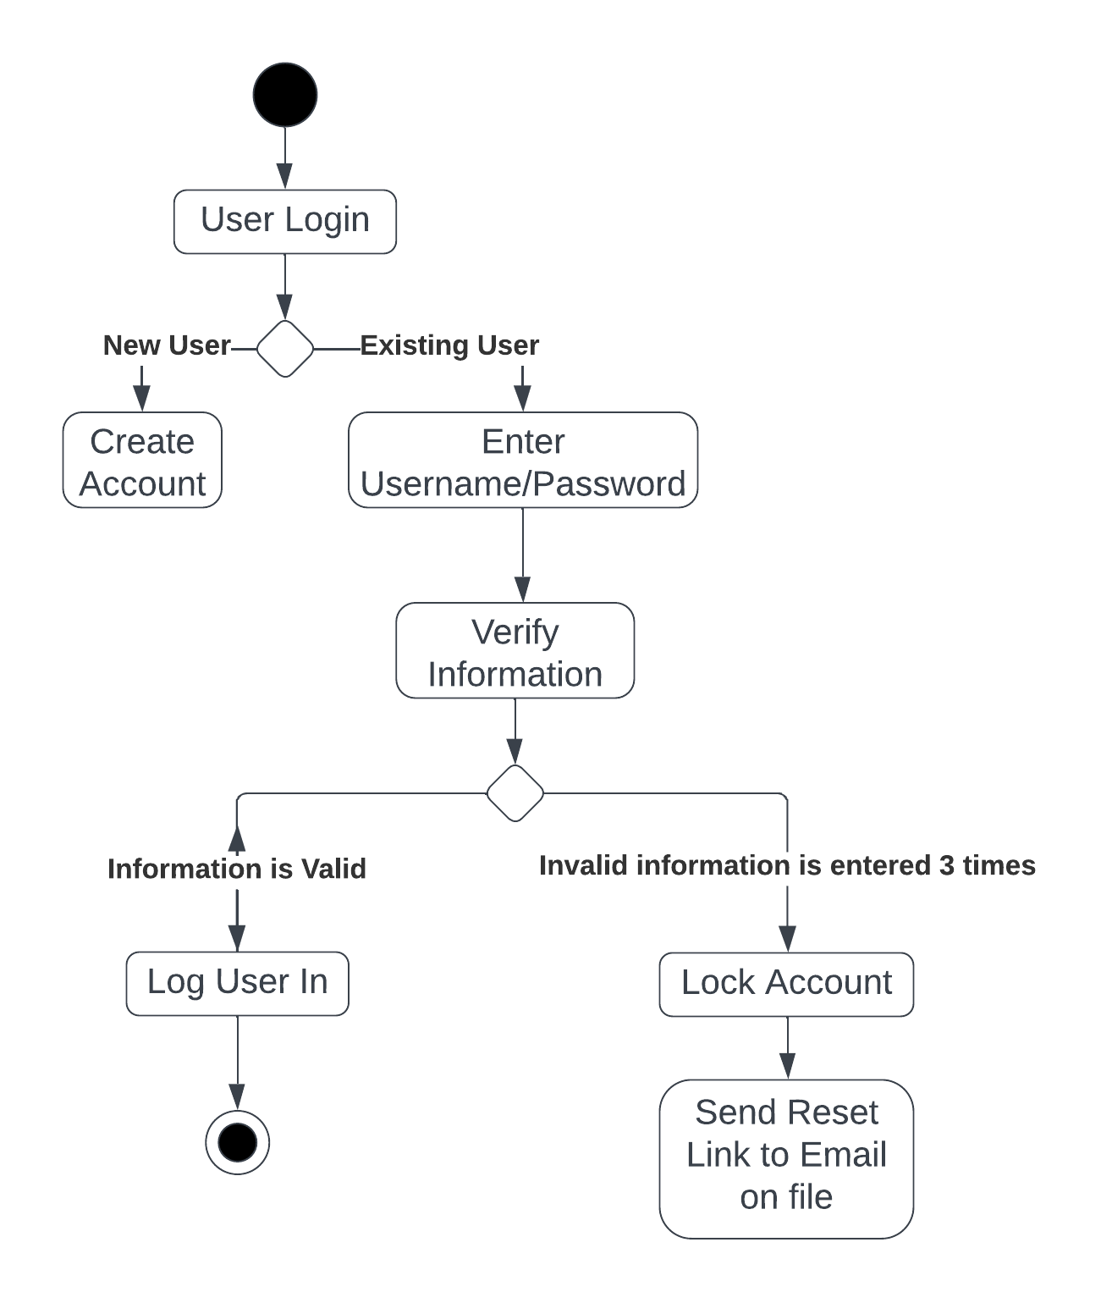

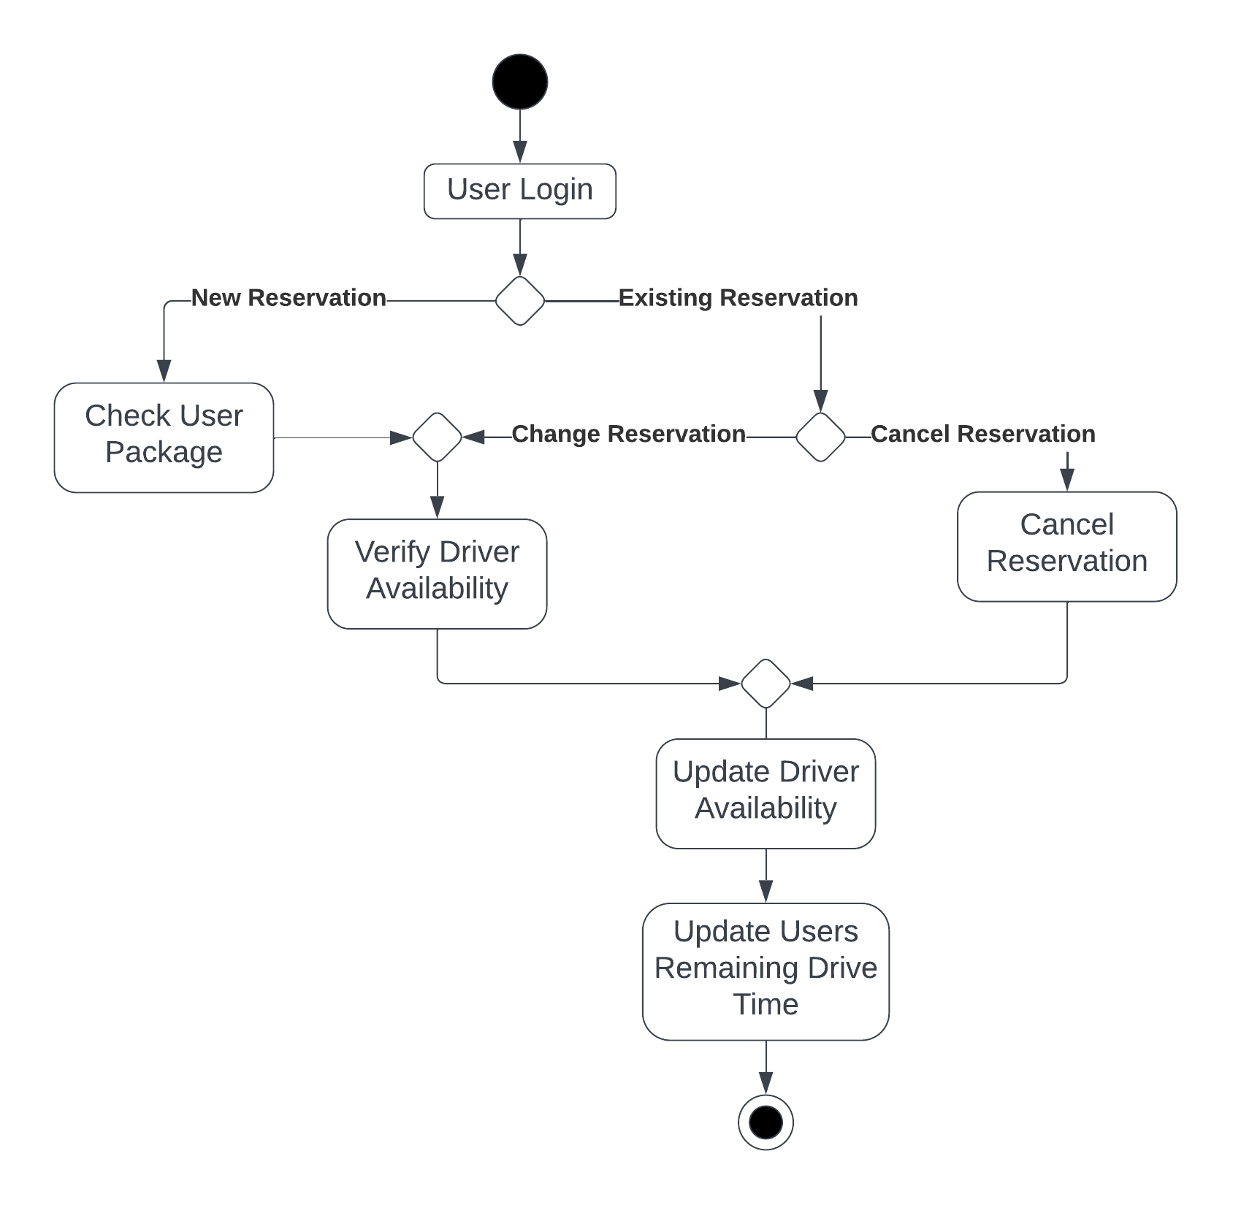

### UML Sequence Diagram

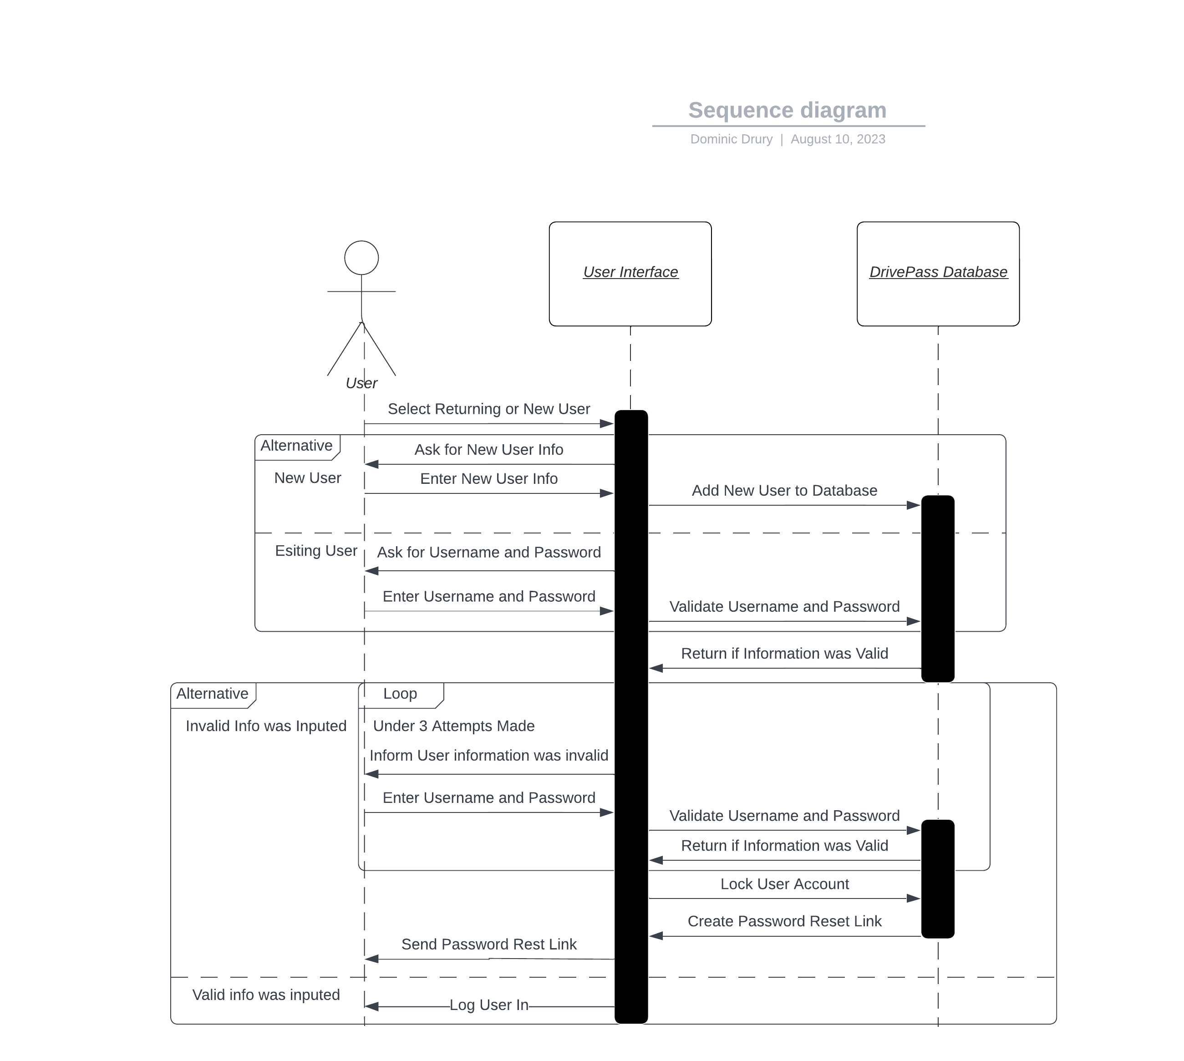

### UML Class Diagram

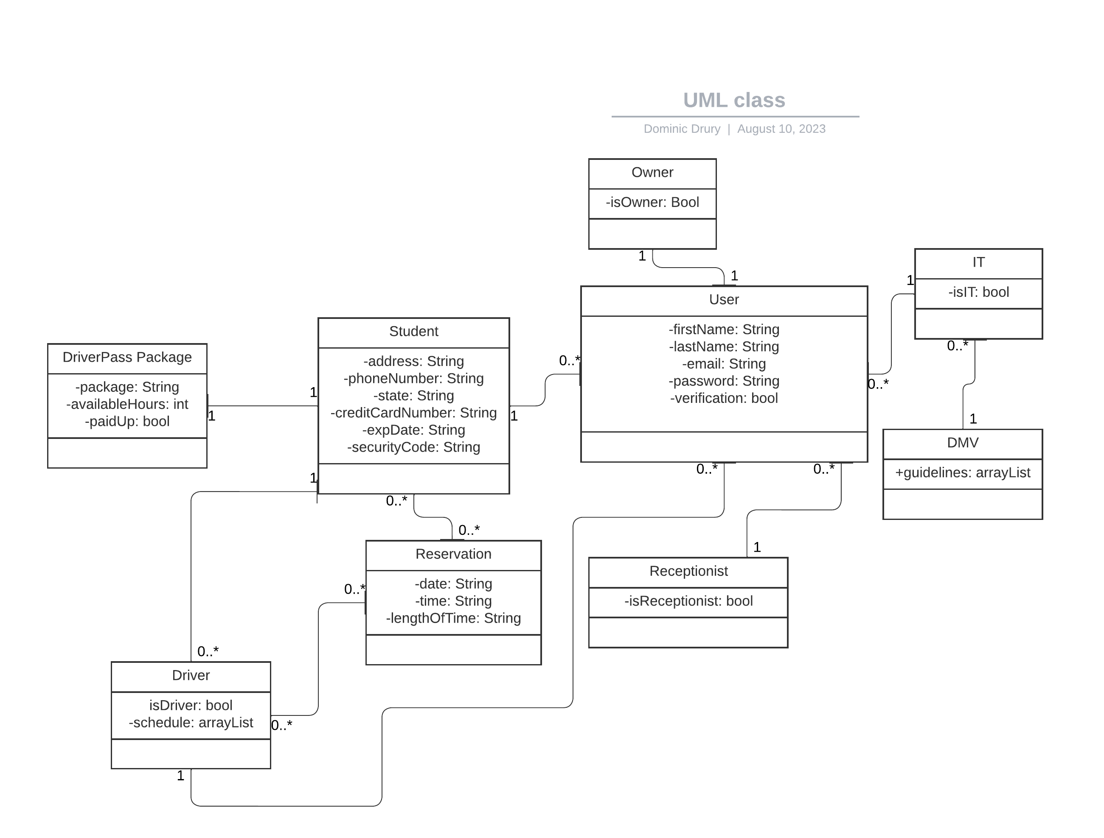

## Technical Requirements

Based on the diagrams above, I would describe the technical requirements of the system as the following:

* Cloud based database for storing data
* Payment management servicer for managing payments (third party)
* Web Based interface for use across all types of devices and at any location